IDENTIFICATION PHASE

INTRODUCTION
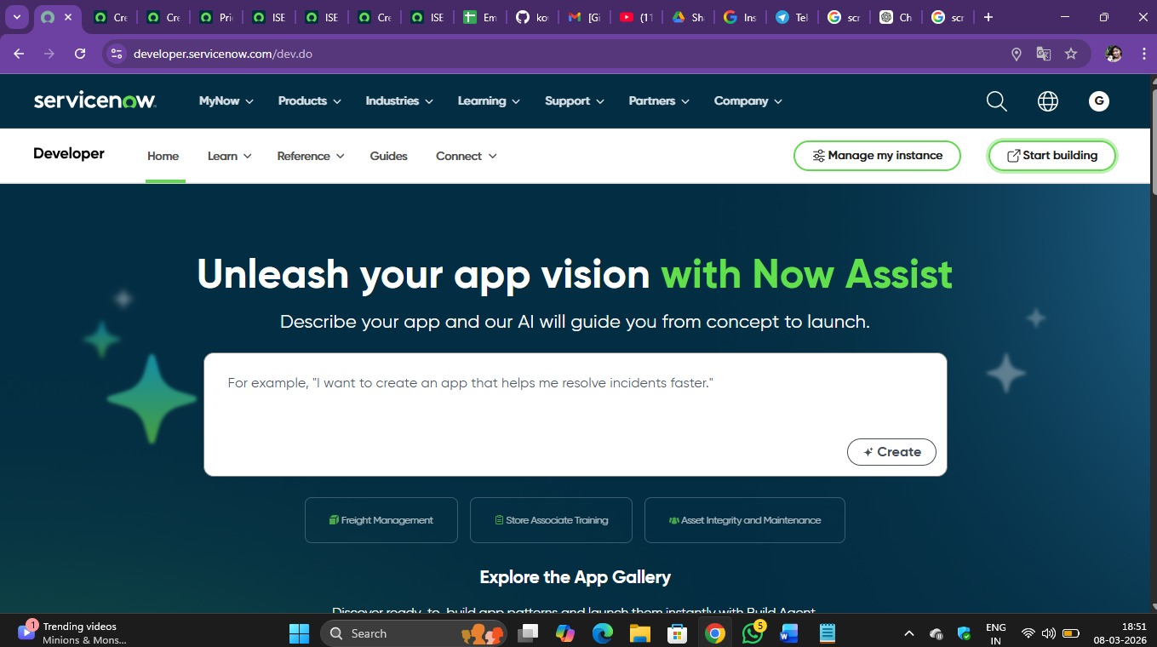
In today’s digital organizations, IT service management platforms are widely used to manage operations, employee information, and service requests. ServiceNow is one of the most popular cloud‑based platforms used by companies to automate workflows and manage incidents effectively.
Organizations often maintain employee information in external systems such as HR databases or spreadsheets. Importing this data manually into ServiceNow can be time‑consuming and may result in incomplete or inaccurate records.
To overcome this problem, ServiceNow provides features such as Import Sets that allow administrators to import large amounts of data from external files such as Excel or CSV.
Along with data import, it is also important to make related information easily accessible to incident handlers. Using dot walking, administrators can display related data such as department or manager details directly within forms.

PROJECT OVERVIEW
This project focuses on automating employee data import into ServiceNow and improving incident handling efficiency.
Employee information such as name, email, department manager, and manager email is imported from an external file using Import Sets.
After the data is imported, incidents can be assigned to employees and the system will automatically display department and manager details using dot walking.
Additionally, dictionary override is used to modify the default priority value specifically for incidents so that incidents receive appropriate attention.

PURPOSE
The purpose of this project is to improve the efficiency and accuracy of incident management in ServiceNow.
By automating employee data import and displaying related information directly within incident forms, incident handlers can resolve issues faster and more effectively.
Customizing the priority field ensures that incidents are given the appropriate urgency level compared to other tasks.

PROBLEM STATEMENT
Organizations frequently receive employee data updates from external systems.
Manually entering this information into ServiceNow is inefficient and increases the risk of errors.
Incident handlers may also need additional information such as department or manager details, which can slow down resolution if the information is not easily accessible.

SELECTED IDEA
The selected solution is to automate employee data import using Import Sets and Transform Maps.
Dot walking is used to display department and manager information on incident forms.
Dictionary override is applied to customize the default priority value for incidents without affecting the parent task table.

